AGRIPOLL MANUAL

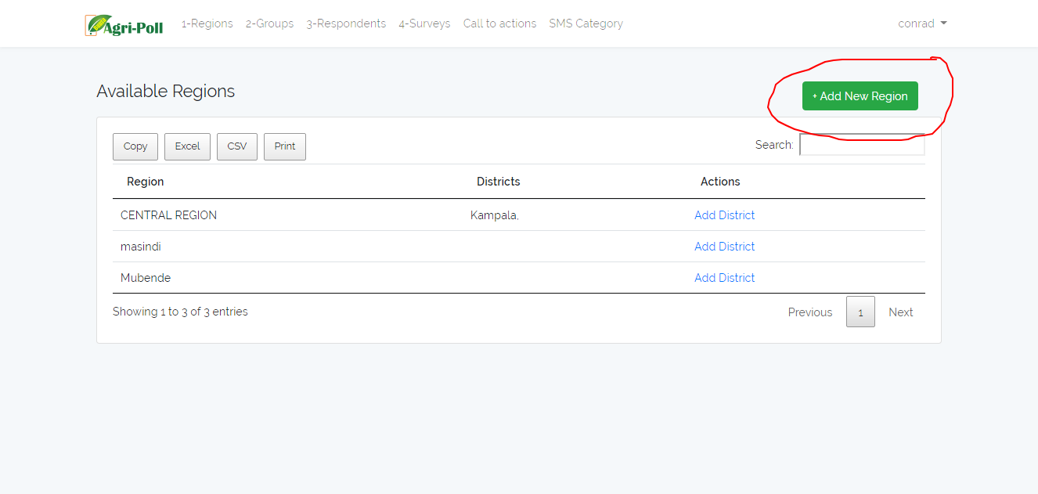

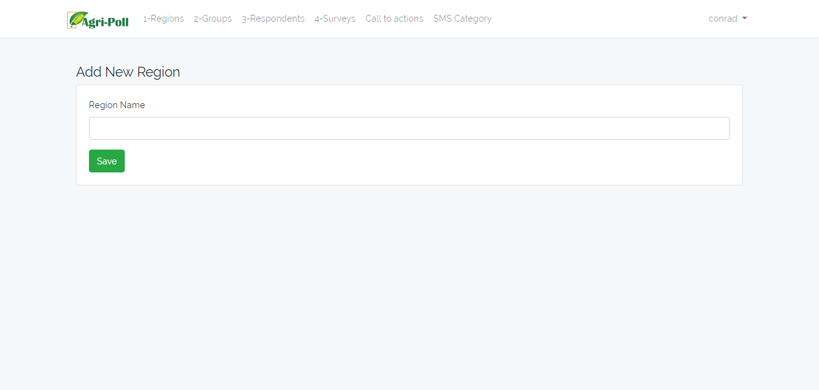

Add region e.g Central, Western,Eastern,Northern or any category of your choice.From which you are respondents you are going to register belong

Adding Regions:

-Add region e.g Central, Western,Eastern,Northern or any category of your choice.From which you are respondents you are going to register belong

-Type the Region name and click save button

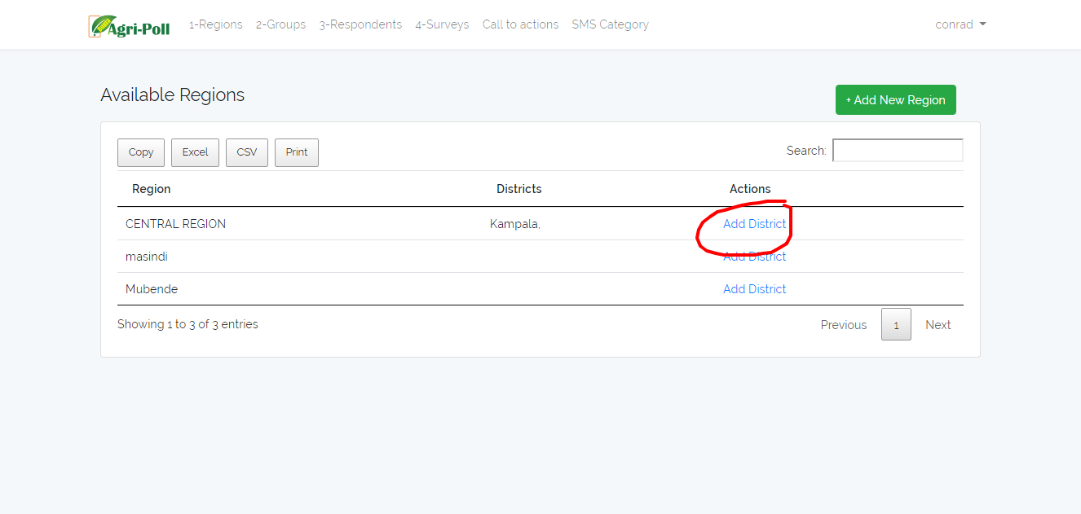

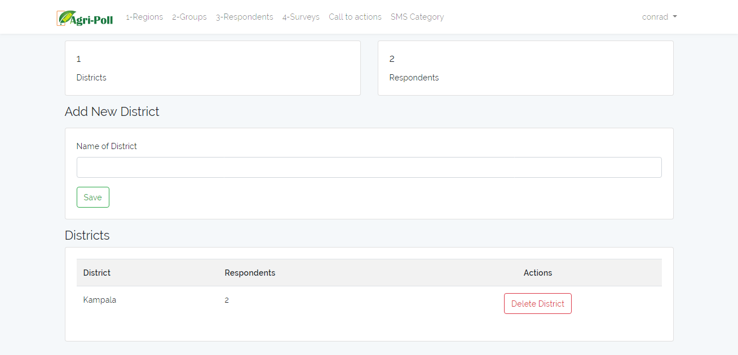

Adding Districts:

-Add Districts to a specific region e.g kabala,mbarara,kampala, masaka etc any of your choice to register in the system

-Add District Name and click the save button

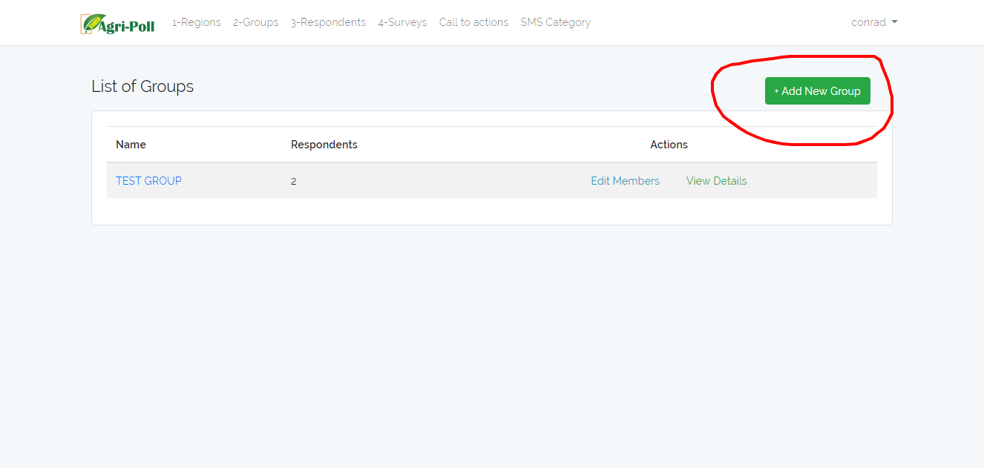

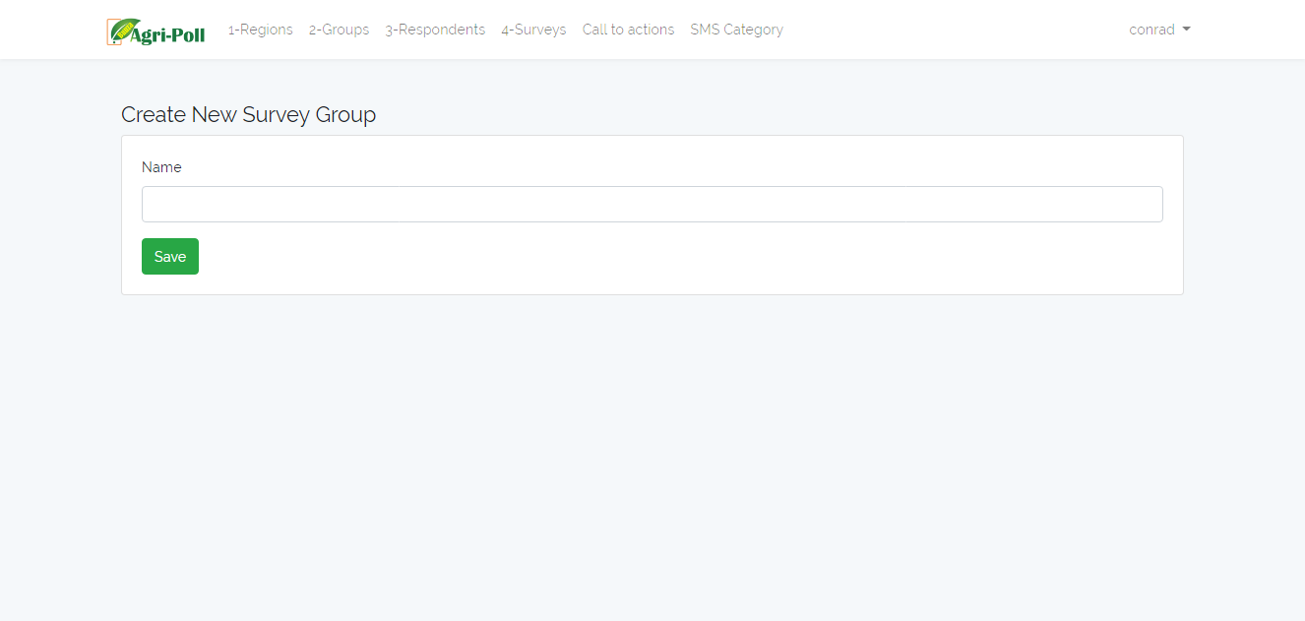

-Add Groups:

-you can add a new group under which farmers will be grouped together e.g Kabale farmers Association Group

-Type the Group name and click the save button

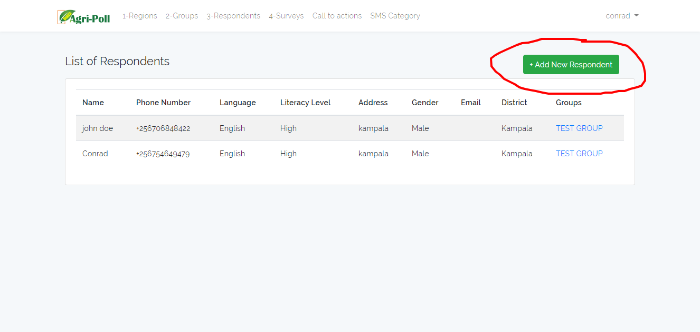

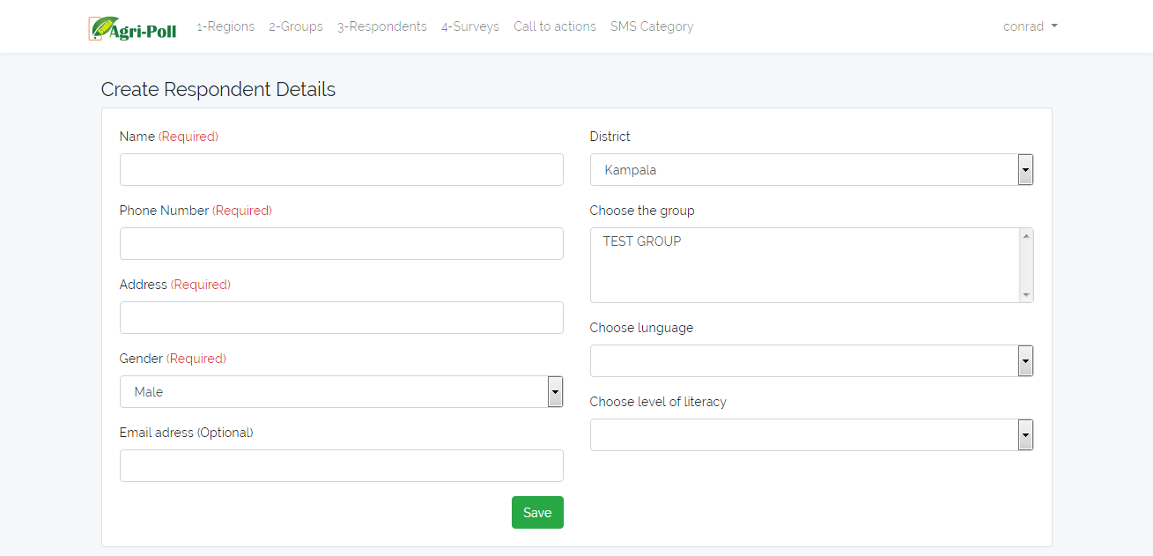

-Add Respondent:

-You can add respondent/farmer to a specific group and District they hail from respectively

-Fill in all the details of the respondent

NOTE: - select the District and Group the Respondent belongs to

-After click the save button

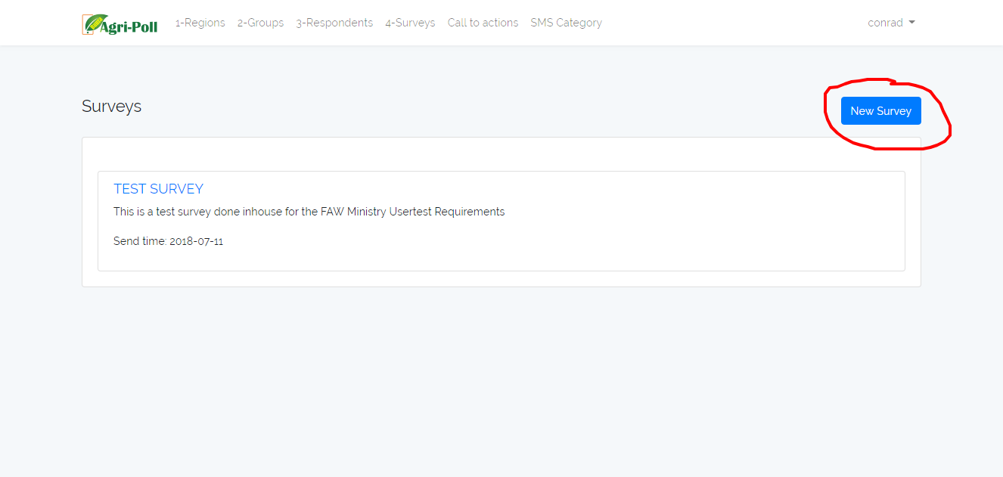

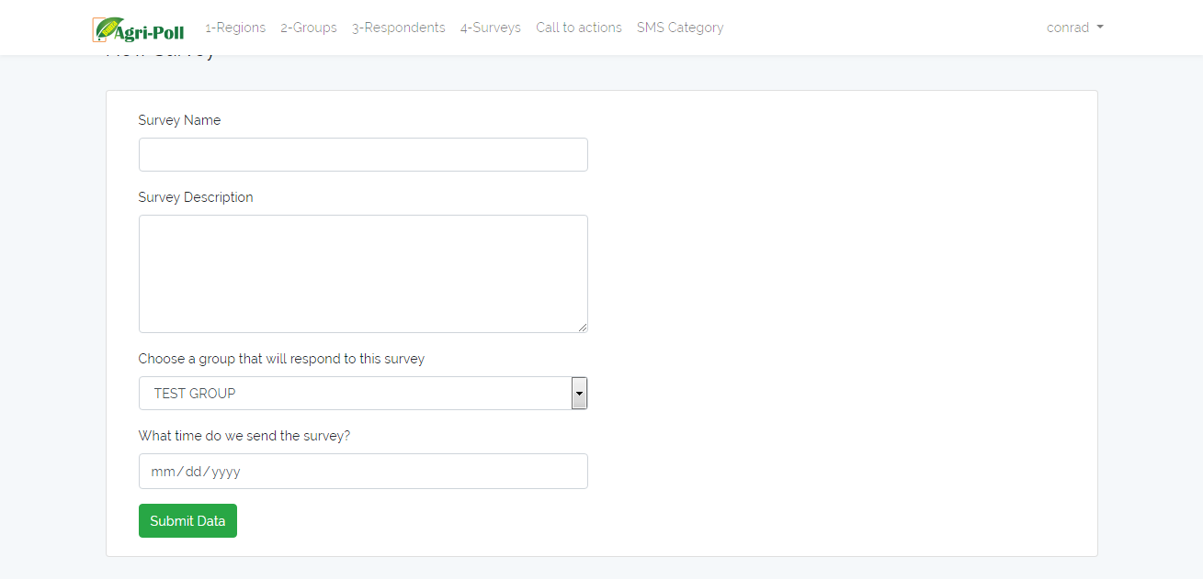

Add Survey:

-Register a New Survey Title and Description

-Type the Survey Details with full description about the survey and the group to be sent to and the scheduled date for the survey to be sent out to respondents

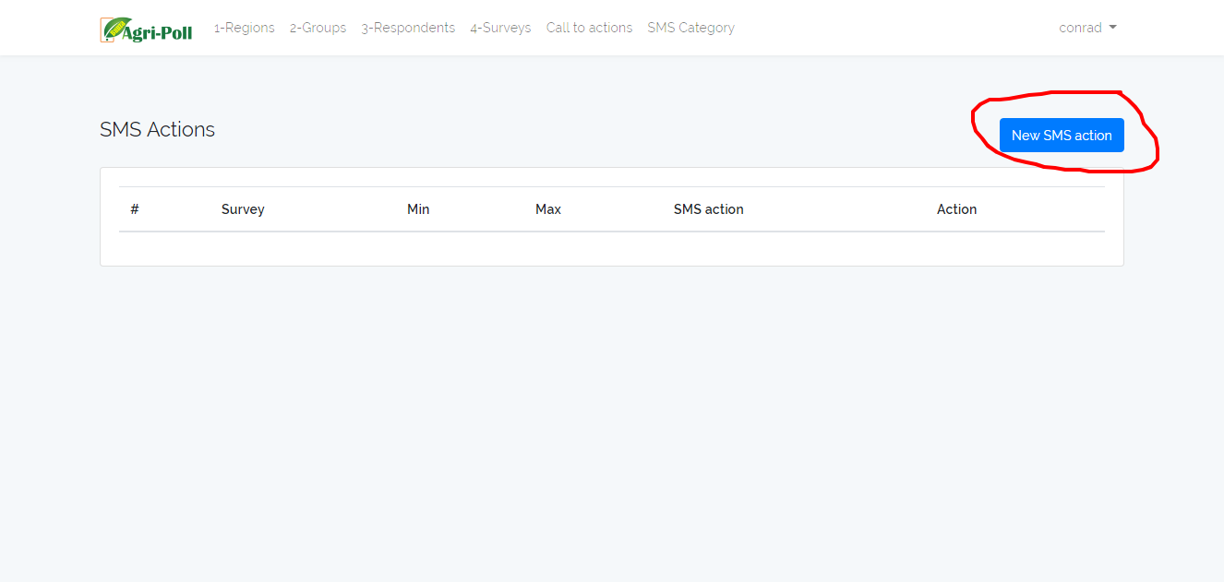

Add Call to Action

-Add a call to action to be sent to respondent after survey is completed

-Set Specific responses for messages/responses from respondents after the survey is completed

NOTE: These messages are possible solutions or advice given to the respondents after the survey is completed and they have received their reward.